18th INTERNATIONAL BIOLOGY OLYMPIAD
July 15 – 22, 2007


PRACTICAL EXAM 3
GENETICS

TASK A. Sequence confirmation of a cDNA 15 marks

TASK B. Genetics of coat colour in dogs 16 marks

TASK C. Genetic control of seed coat colour and seed shape in beans
20 marks

Time allowed: 90 minutes

WRITE ALL ANSWERS IN THIS EXAM BOOKLET.

WRITE YOUR 4-DIGIT STUDENT CODE IN THE BOX BELOW AND ON THE TOP OF EACH PAGE OF THIS BOOKLET

Student code:

TASK A. Sequence Confirmation of a cDNA (15 marks)

Objective: To isolate plasmid DNA containing a cDNA of interest and to determine the sequence of the cDNA.

Introduction:
To over-express a gene of interest in a plant or animal you must first isolate the gene of interest in the form of a cDNA. You have done this and in order to amplify this DNA, you have cloned it into the pBluescript SK plasmid vector which you have subsequently used to transform bacteria cells. You must now carry out a quick plasmid preparation to isolate the plasmid and confirm the sequence of your cDNA insert.

Materials Quantity
➢ Bacterial cell culture 4 mL
➢ 1.5 mL microcentrifuge tubes 10
➢ Microcentrifuge rack 1
➢ P1000 micropipettor 1
➢ Box of 200-1000 uL pipette tips 1
➢ GET buffer (1.5 mL tube) 1 mL
➢ 10% Sodium Dodecyl Sulphate (1.5 mL tube) 1 mL
➢ 2 N NaOH (1.5 mL tube) 1 mL
➢ 3 M Potassium 5 M Acetate (1.5 mL tube) 1 mL
➢ 95% ethanol (Falcon tube) 3 mL
➢ Distilled water (Falcon tube) 3 mL
➢ Timer 1
➢ Tube labels 2
➢ Marker pen 1
➢ Red card 1
➢ Garbage (tips & tubes) bag 1
➢ Access to a microcentrifuge
➢ Access to vortex

NOTE: Before beginning this task, be sure that you have all the materials listed above. If you do not, raise your RED card to call a lab assistant.

Procedure
- Pipette 2 x 1.5 mL of bacterial culture into 2 x 1.5 mL microcentrifuge tubes.

- Centrifuge the tubes in a benchtop microcentrifuge for 1 minute - make sure that the centrifuge rotor is BALANCED.

- Completely remove and discard back into the overnight tube the growth medium from each tube.

- Add 100 uL of GET (Glucose-EDTA-Tris) buffer pH 7.9 to the cell pellet (no need to cap the tubes) - vortex vigorously to resuspend the pellet and leave at room temperature for 5 minutes.

- In a separate 1.5 mL microcentrifuge tube, make a combined mixture of 1% SDS and 0.2 N NaOH in water to a final volume of 1 mL.

- To each tube from 4. above add 200 uL of this freshly prepared mixture of 1% SDS and 0.2 N NaOH - cap the tubes and invert 4-5 times.

- Incubate at room temperature for 3 minutes.

- To each tube add 150 uL 5M KOAc (3 M potassium and 5 M acetate), cap the tubes and shake briefly by hand to mix.

- Incubate at room temperature for 3 minutes.

- Centrifuge the tubes for 3 minutes - full speed in microcentrifuge - remember to balance the rotor.

- Label 2 clean microcentrifuge tubes with your 4-digit student code number.

- Pipette the supernatant from each of the centrifuged tubes into each of the clean tubes. Discard the original tube which now contains a white pellet - this is bacterial chromosomal DNA.

- Add 800 uL of 95% ethanol to each tube. Cap the tubes, shake vigorously by hand for 10 sec and leave on the bench for 10 minutes.
- Centrifuge the tubes for 5 minutes - full speed in microcentrifuge.

- Pour off the supernatant from each tube, cap the tube and raise your RED card.

- The lab assistant will check your pellet (5 marks for a white pellet).

- The lab assistant will then give you the sequence trace for your plasmid and cDNA. The cDNA was sequenced from the T₇ promoter.

18. Check your sequence against that for the pBluescript vector and answer the questions on page 5..

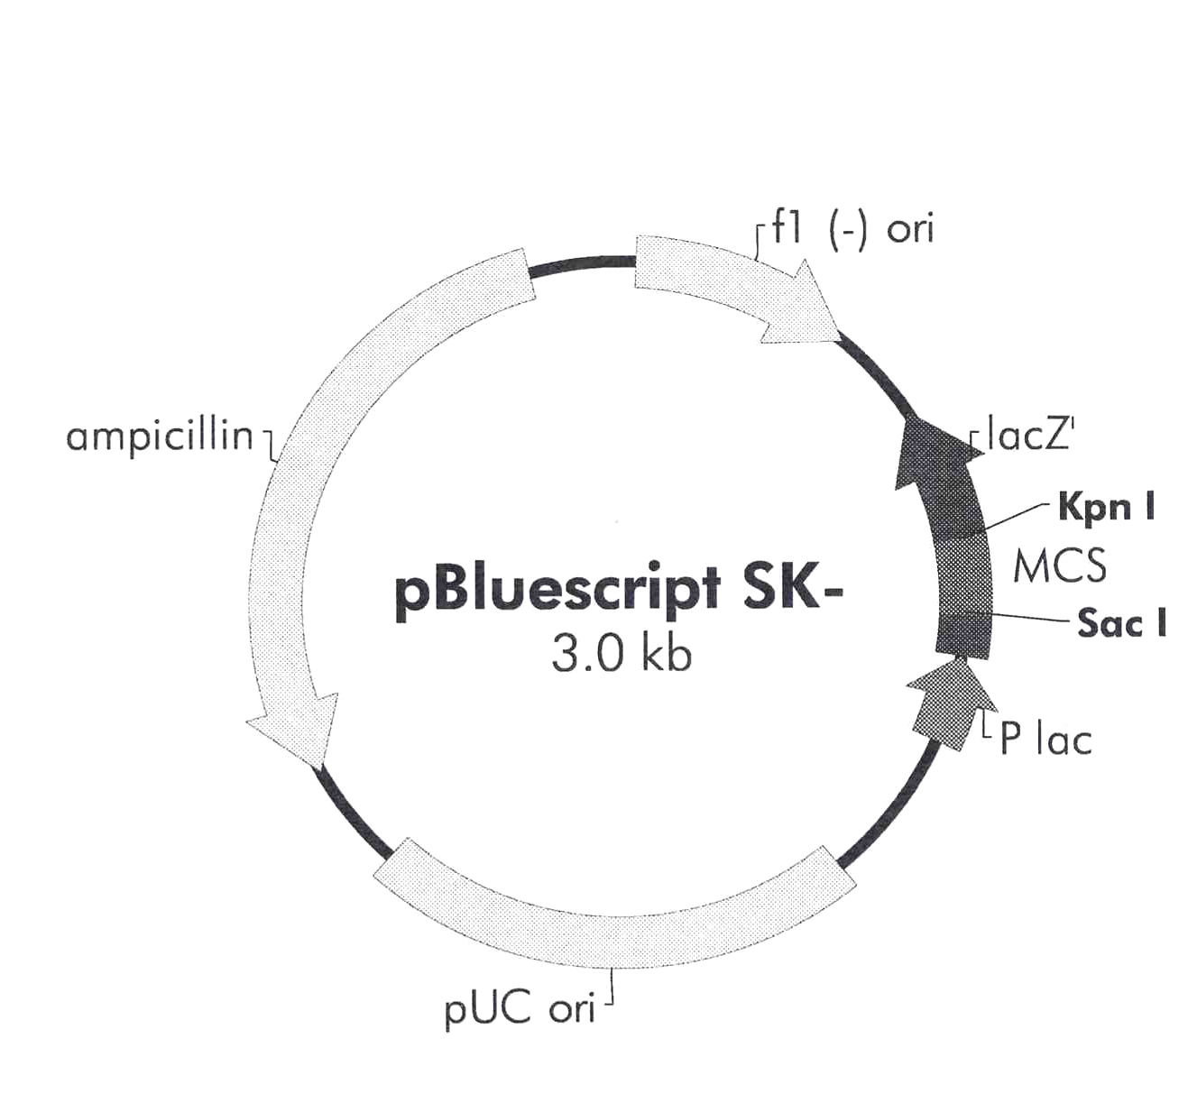
PLASMID MAP AND MULTIPLE CLONING SITE SEQUENCE FOR pBLUESCRIPT
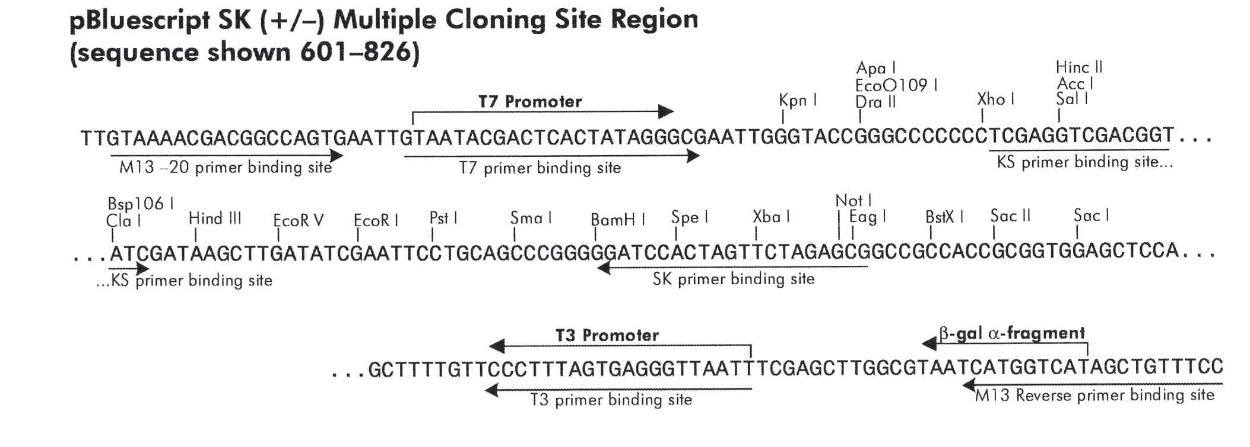

Questions (10 marks)

- The enzyme site into which you cloned your fragment of DNA is __________.
NOTE: The first letter of the enzyme’s name is located above the first nucleotide of its recognition sequence. (2 marks).

- List the first 20 nucleotides of your fragment of DNA. (2 marks)

 | 1 | 2 | 3 | 4 | 5 | 6 | 7 | 8 | 9 | 10 | 11 | 12 | 13 | 14 | 15 | 16 | 17 | 18 | 19 | 20
nucleotide

- The start codon for the sequence that when translated would give rise to a protein. Using the genetic code table provided on page 6, and starting with the start codon, translate the first 21 nucleotides into their appropriate amino acids. (4 marks)

Amino acid
 | 1 | 2 | 3 | 4 | 5 | 6 | 7 | 8 | 9 | 10 | 11 | 12 | 13 | 14 | 15 | 16 | 17 | 18 | 19 | 20 | 21
nucleotide

4. (a) If the nucleotide at position 13 was mutated to an ‘A’, what would be the corresponding amino acid? (1 mark)

(b). If the nucleotide at position 14 was mutated to an ‘A’, what would be the corresponding amino acid? (1 mark)

GENETIC CODE TABLE

This table shows the 64 codons and the amino acid each codon codes for. The direction is 5' to 3'.
 |  | 2nd base
 |  | U | C | A | G
1st  base | U | UUU (Phe/F)Phenylalanine  UUC (Phe/F)Phenylalanine  UUA (Leu/L)Leucine  UUG (Leu/L)Leucine | UCU (Ser/S)Serine  UCC (Ser/S)Serine  UCA (Ser/S)Serine  UCG (Ser/S)Serine | UAU (Tyr/Y)Tyrosine  UAC (Tyr/Y)Tyrosine  UAA Ochre (Stop)  UAG Amber (Stop) | UGU (Cys/C)Cysteine UGC (Cys/C)Cysteine  UGA Opal (Stop)  UGG (Trp/W)Tryptophan
1st  base | C | CUU (Leu/L)Leucine  CUC (Leu/L)Leucine  CUA (Leu/L)Leucine  CUG (Leu/L)Leucine | CCU (Pro/P)Proline  CCC (Pro/P)Proline  CCA (Pro/P)Proline  CCG (Pro/P)Proline | CAU (His/H)Histidine  CAC (His/H)Histidine  CAA (Gln/Q)Glutamine  CAG (Gln/Q)Glutamine | CGU (Arg/R)Arginine  CGC (Arg/R)Arginine  CGA (Arg/R)Arginine  CGG (Arg/R)Arginine
1st  base | A | AUU (Ile/I)Isoleucine  AUC (Ile/I)Isoleucine  AUA (Ile/I)Isoleucine  AUG (Met/M)Methionine | ACU (Thr/T)Threonine  ACC (Thr/T)Threonine  ACA (Thr/T)Threonine  ACG (Thr/T)Threonine | AAU (Asn/N)Asparagine  AAC (Asn/N)Asparagine  AAA (Lys/K)Lysine  AAG (Lys/K)Lysine | AGU (Ser/S)Serine  AGC (Ser/S)Serine  AGA (Arg/R)Arginine  AGG (Arg/R)Arginine
1st  base | G | GUU (Val/V)Valine  GUC (Val/V)Valine  GUA (Val/V)Valine  GUG (Val/V)Valine | GCU (Ala/A)Alanine  GCC (Ala/A)Alanine  GCA (Ala/A)Alanine  GCG (Ala/A)Alanine | GAU (Asp/D)Aspartic acid  GAC (Asp/D)Aspartic acid  GAA (Glu/E)Glutamic acid  GAG (Glu/E)Glutamic acid | GGU (Gly/G)Glycine  GGC (Gly/G)Glycine  GGA (Gly/G)Glycine  GGG (Gly/G)Glycine

Task B. Genetics of Dog Coat colour (16 marks)

Materials
➢ coloured photograph of four breeds of dog

Procedure

1. Examine the colour photographs of the four dogs. The dominance relationships for coat colour is, from left to right,

K – solid black; k – hair shaft changes colour (agouti)
E – Wildtype; e – red
MM – White; Mm – Merle (intermingling of white hair with coloured hair) ;
mm – coloured
a^{w} – hair shaft changes colour 3 times; a^{y} – Sable (hair red with black tip);
a^{t} – black and tan; a – black

2. The genotypes of the dogs shown in the colour photographs are

Shetland Sheepdog = k/k, E/E, a/a, M/m

Australian Shepherd = k/k, E/E, at/at, M/m

German Shepherd Dog = k/k, E/E, a/a, m/m
Tervuren = k/k, E/E, a^{y}/a^{y}, m/m

3. Using the dogs shown in the coloured photographs, determine ALL possible genotypes and phenotypes of puppies from the matings listed in the table on the page 8.

(2 marks per mating genotype and 2 marks per mating phenotype = 16 marks)

4. Write your answers in the appropriate column of the following table:
Mating | Genotype | Phenotype
Shetland Sheepdog x Australian Shepherd
Shetland Sheepdog x German Shepherd
German Shepherd x Tervuren

Tervuren x Australian Sheepdog

Task C. Genetic Control of Seed Coat Colour and Seed Shape in Beans (20 points)

Material
➢ 1 plastic bag containing flat red parent beans

➢ 1 plastic bag containing round red parent beans

➢ 1 plastic bag containing F₁ seeds (flat yellow) from the cross between the parent beans

➢ 1 plastic bag of bean seed representing one seed from each of 250 F₂ plants

To help you answer the questions below, fill in the following table:

Generation | Seed shape  (round or flat) | Seed coat colour  (yellow or red)
Parent 1
Parent 2
F₁ from a cross between these two parents

Answer the following questions.

1. Is the seed coat colour controlled by (circle one)

(i) one gene

(ii) more than one gene? (1 mark)

2. a) Red seed coat colour is (circle one)

(i) dominant

(ii) partially dominant

(iii) recessive (1 mark)

b) Round seed shape is (circle one)

(i) dominant

(ii) partially dominant

(iii) recessive (1 mark)

3. (a) There are four phenotypes in your sample of F₂ seeds. Classify the seeds into these phenotypic classes and write the number of each phenotype in the table below. (2 marks)

Phenotype  (seed colour/ seed shape) | Number of seeds  (= number of F₂ plants)
round, red
flat, red
round, yellow
flat, yellow
Total

Use these F2 segregation data to answer the following questions:

4. (a) How many genes control seed shape? (1 mark)

(b) How many round beans and how many flat ones would you expect in a population this size?

ROUND ______________ FLAT __________ (2 marks)

(c) Is this segregation ratio significantly different from the observed ratio (circle one)?

YES NO (3 marks)

(d) How many genes control seed shape in this population? ___ (1 mark)

5. (a) How many genes control red seed coat colour? ______ (1 mark)

(b) How many red beans and how many yellow beans would you expect in a population this size?

RED ______________ YELLOW __________ (3 marks)

(c) Is this segregation ratio significantly different from the observed ratio? (circle one)

YES NO (3 marks)

(d) How many genes control seed coat colour in this population? __ (1 mark)

Chi-square Distribution
 | Probability
df | 0.95 | 0.90 | 0.80 | 0.70 | 0.50 | 0.30 | 0.20 | 0.10 | 0.05 | 0.01 | 0.001
1 | 0.004 | 0.02 | 0.06 | 0.15 | 0.46 | 1.07 | 1.64 | 2.71 | 3.84 | 6.64 | 10.83
2 | 0.10 | 0.21 | 0.45 | 0.71 | 1.39 | 2.41 | 3.22 | 4.60 | 5.99 | 9.21 | 13.82
3 | 0.35 | 0.58 | 1.01 | 1.42 | 2.37 | 3.66 | 4.64 | 6.25 | 7.82 | 11.34 | 16.27
4 | 0.71 | 1.06 | 1.65 | 2.20 | 3.36 | 4.88 | 5.99 | 7.78 | 9.49 | 13.28 | 18.47

- THE END –

HAVE YOU WRITTEN YOUR 4-DIGIT STUDENT CODE ON THE TOP OF EACH PAGE?

